Vision Document

for

BackTrack

**Version 2.0**

**Prepared by Ho Siu Chuen, Leung Hang Chun,**

**Lui Kin Ping, Tam Man Hon, Wu Zekai**

**Team AB**

**28/10/2019**

**Table of Contents**

Table of Contents ii

Revision History ii

1. Business Requirements 1

1.1. Background 1

1.2. Business Opportunity 1

1.3. Vision Statement 1

1.4. Business Assumptions and Dependencies 1

2. Scope and Limitations 2

2.1. Major Features 2

2.2. Limitations and Exclusions 2

3. Stakeholders 3

3.1. Stakeholder Profiles 3

4. Delivery and Deployment 4

4.1. Product Roadmap 4

4.2. Release Plan 4

4.3. Deployment Considerations 5

**Revision History**

|  |  |  |  |
| --- | --- | --- | --- |
| **Name** | **Date** | **Reason For Changes** | **Version** |
| Team AB | 10/10 | Initialization of document | 1.0 |
| Team AB | 28/10 | Release Plan change due to request of customers | 2.0 |

# Business Requirements

## Background

In the past, Digital Services Group of Pendragon, an engineering consultancy, was free to adopt any methods of cooperation and production to facilitate their design activities.

But now with the gradual shift of using Scrum as the basic framework, a web-based project management tool with sufficient features and deliverables is required to achieve the goal of the creation, management and tracking of projects backlog and sprint backlogs with good visibility to all concerned.

As a result, our team is developing BackTrack, a collaboration tool, to facilitate the customer to have a better management and overview of the projects they are working or worked on.

## Business Opportunity

Engineering consulting firms usually have a large variety of on-going projects and have extensive network of partners who specialize in hardware, software, prototyping and manufacturing. Since those are arduous, complex and time-consuming, implementing an effective project management tool is necessary and can help streamline the process. Every client has strategic goals and the projects that we do for them advance those goals.

With the use of scrum product backlog and sprint backlog, more accurate estimation of items in PBIs can be made based on clearer content and more detailed information. With the deployment of the product, and the feedback from the market, the product backlog becomes a larger, more detailed list as the demand never stops changing, the product backlog is an up-to-date artifact.

## Vision Statement

BackTrack is built for production companies which need a collaboration tool to ease the creation, management and monitoring processes when producing projects. Unlike many products on the market, BackTrack is based on web, this allows the users to access the project backlogs details anywhere. Plus, the product uses a clearer and simpler interface which makes customers from different industries and background have no trouble using it. The customers can have their full focus on their project without spending much time adapting to the collaboration tool.

## Business Assumptions and Dependencies

AS-1: The product is a web-based tool and designed for storing confidential business information.

AS-2: Secure and reliable database service and internet transmission are essential for the implementation.

AS-3: All staff of developers, managers and technicians are well-educated for using the application and tool thus we should get familiar with using the tools in a short period of time.

DE1: Python on Django 2.x is available to us

# Scope and Limitations

## Major Features

**FE-1:** Creating and viewing projects.

**FE-2**: Defining, creating, viewing sprint.

**FE-3:** Creating, editing, viewing, and deleting product backlog items.

**FE-4:** Copying product backlog items to create new sprint backlog items.

**FE-5:** Creating, editing, viewing, and deleting sprint backlog tasks.

**FE-6:** Providing system access through Internet and mobile applications.

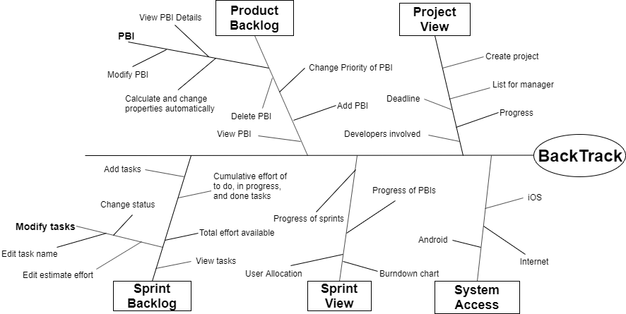

**Figure 1.** Partial feature tree of BackTrack.

## Limitations and Exclusions

**LI-1:** PBI refinement would only be able to be done by deleting original item and creating new refined items

# Stakeholders

**3.1 Stakeholder Profiles**

|  |  |  |
| --- | --- | --- |
| **Stakeholder** | **Major Value** | **Major Interests** |
| Pendragon management | Improve the productivity; cost savings | Performance reviews are  statistics on effectiveness easier to gather;  employee time saving |
| DSG manager | Better management; Streamlined business processes | Ease of management(e.g. analysis and visualization of project metrics); automation in sending emails |
| Developer | More effective to select suitable process model | Simplicity of use; Adequacy of task information; |
| Technical support personnel | Time saving; convenience;  better division of labour | Simplicity of work; data protection |
| External clients | Better security of the data | data protection |

# Delivery and Deployment

## Product Roadmap

|  |  |  |  |
| --- | --- | --- | --- |
| **Feature** | **Release 1** | **Release 2** | **Release 3** |
| Target | Q3, 2019 | Q4, 2019 | Q2, 2020 |
| FE-1, Projects | Create project and Show project full details | Visualize timestamp of project progress | Show history of projects |
| FE-2, Sprint Progress | Create and view sprint | Add burndown chart and other visual aids |  |
| FE-3, Product backlog | Create, edit, view and delete PBIs | Add search function |  |
| FE-4, Move PBIs | Fully implemented |  |  |
| FE-5, Sprint backlog | Create, edit, view and delete sprint backlog tasks | View current doing tasks of specific owner |  |
| FE-6, System access | Internet access | iOS mobile app | Android mobile app |

## Release Plan

**Release 1:**

|  |  |  |
| --- | --- | --- |
| **Sprint 1** | **Sprint 2** | **Sprint 3** |
| **Create Product Backlog Items**  **View Product Backlog**  **View Product Backlog Items details**  **Edit and delete Product Backlog Items**  **Web-enabled** | **Create Sprint Backlog Items from Product Backlog Items**  **View Sprint Backlog**  **Create Sprint tasks**  **Edit and delete Sprint tasks** | **Login System**  **Create Project**  **View Project**  **Create Sprint**  **View Sprint** |

## Deployment Considerations

The web server software will need to be implemented in Python on Django 2.x. It will be built with SQLite as DBMS. The mail service is required to send mail to users. Any corresponding infrastructure changes must be in place at the time of the second release. iOS application will be released on the second release and the Android one will be on the third release since iOS app release may have a longer review time for the application to be put on the app store. Readme text or videos no more than three minutes shall be developed to acknowledge the usage for different users in various versions of BackTrack.